Low-Level Design (LLD) 

## Low-Level Design

**Crop Production Prediction**

|  |  |
| --- | --- |
| **Written By** | Mayank Rai |
| **Document Version** | 1 |
| **Last Revised Date** |  |

Low-Level Design (LLD) 

## DOCUMENT CONTROL

### Change Record:

|  |  |  |  |
| --- | --- | --- | --- |
| **VERSION** | **DATE** | **AUTHOR** | **COMMENTS** |
| 1 | 29- Aug- 2021 | Author 1 | Introduction and architecture defined |
| 1 |  |  |  |
|  |  |  |  |
|  |  |  |  |

### Reviews:

|  |  |  |  |
| --- | --- | --- | --- |
| **VERSION** | **DATE** | **REVIEWER** | **COMMENTS** |
|  |  |  |  |

### Approval Status:

|  |  |  |  |  |  |
| --- | --- | --- | --- | --- | --- |
| **VERSION** | **REVIEW**  **DATE** | **REVIEWED BY** |  | **APPROVED BY** | **COMMENTS** |
|  |  |  |  |  |  |

## Table of content

Low-Level Design 1

DOCUMENT CONTROL 2

Change Record: 2

Reviews: 2

Approval Status: 2

Table of content 3

1. Introduction 4

2. Excel ribbon 5

3. Architecture Description 10

4. Unit Test Cases 11

Low-Level Design (LLD) 

## 1. Introduction

**1.1 What is a Low-Level design document?**

The LDD or Low-level design document (LLDD) aims to give the internal logic design of the actual program code for the Crop Production Prediction dashboard. LDD describes the class diagrams with the methods and relations between classes and programs specs. It describes the modules so that the programmer can directly code the program from the document.

**1.2 Scope**

Low-level design (LLD) is a component-level design process that follows a step-by-step refinement process. The process can be used for designing data structures, required software architecture, source code and ultimately, performance algorithms. Overall, the data organization may be defined during requirement analysis and then refined during data design work.

## 2. Excel ribbon

Microsoft Excel ribbon is the row of tabs and icons at the top of the Excel window that allows you to quickly find, understand and use commands for completing a certain task. It looks like a kind of complex toolbar, which it is.

The ribbon first appeared in Excel 2007 replacing the traditional toolbars and pull-down menus found in previous versions. In Excel 2010, Microsoft added the ability to personalize the ribbon.

The ribbon in Excel is made up of four basic components: tabs, groups, dialog launchers, and command buttons.

The ribbon tab contains multiple commands logically subdivided into groups.

A ribbon group is a set of closely related commands normally performed as part of a larger task.

Dialog launcher is a small arrow in the lower-right corner of a group that brings up more related commands. Dialog launchers appear in groups that contain more commands than available space.

The command button is the button you click to perform a particular action.

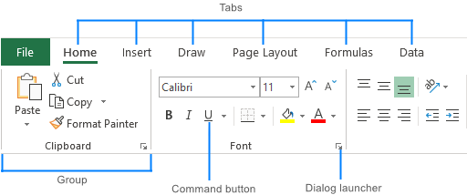

Ribbon tabs

The standard Excel ribbon contains the following tabs, from left to right:

File – allows you to jump into the backstage view that contains the essential file-related commands and Excel options. This tab was introduced in Excel 2010 as the replacement for the Office button in Excel 2007 and the File menu in earlier versions.

Home – contains the most frequently used commands such as copying and pasting, sorting and filtering, formatting, etc.

Insert – is used for adding different objects in a worksheet such as images, charts, PivotTables, hyperlinks, special symbols, equations, headers and footers.

Page Layout – provides tools to manage the worksheet appearance, both onscreen and printed. These tools control theme settings, gridlines, page margins, object aligning, and print area.

Formulas – contains tools for inserting functions, defining names and controlling the calculation options.

Data – holds the commands for managing the worksheet data as well as connecting to external data.

Review – allows you to check spelling, track changes, add comments and notes, protect worksheets and workbooks.

View – provides commands for switching between worksheet views, freezing panes, viewing and arranging multiple windows.

Help – only appears in Excel 2019 and Office 365. This tab provides quick access to the Help Task Pane and allows you to contact Microsoft support, send feedback, suggest a feature, and get quick access to training videos.

Developer – provides access to advanced features such as VBA macros, ActiveX and Form controls and XML commands. This tab is hidden by default and you have to enable it first.

Add-ins – appears only when you open an older workbook or load an add-in that customizes the toolbars or menu.

Contextual ribbon tabs

In addition to the constant tabs described above, the Excel ribbon also has context-sensitive tabs, aka *Tool Tabs*, which show up only when you select a certain item such as a table, chart, shape, or picture. For example, if you select a chart, the *Design* and *Format* tabs will appear under *Chart Tools*.  
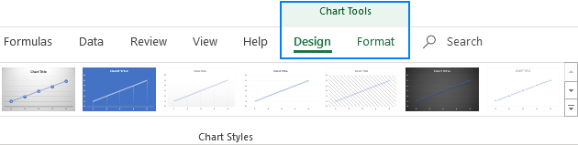

Tip. If you are just starting out in Excel, Ribbon Hero might come in handy. It's a game created by Office Labs to help people explore the most useful features of the Office ribbon.

If you'd like to get as much space as possible for your worksheet data (which is especially the case when using a laptop with a small screen), you can minimize the ribbon by pressing the Ctrl + F1 shortcut.

Or you can hide the ribbon completely by clicking the *Ribbon Display Options* button at the upper-right corner of the Excel window, and then clicking *Auto-hide Ribbon*.  
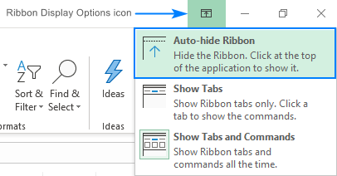

**How to unhide ribbon in Excel**

If suddenly all commands disappeared from your Excel ribbon and only tab names are visible, press Ctrl + F1 to get everything back.

If the entire ribbon is missing, click the *Ribbon Display Options* button and choose Show Tabs and Commands.  
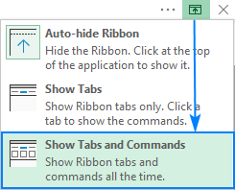

Curious to learn 4 more ways to restore the missing ribbon? Check out [How to show ribbon in Excel](https://www.ablebits.com/office-addins-blog/2019/06/17/excel-ribbon-show-hide-restore/#how-to-show-ribbon-in-Excel).

How to customize Excel ribbon

If you wish to personalize the ribbon for your needs so you know exactly where everything is located, you can easily do that too.

Your entry point to most customizations is the *Customize Ribbon* window under *Excel Options*. And the shortest path to it is to right-click on the ribbon and select Customize the Ribbon… from the context menu:  
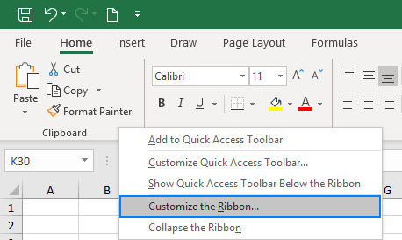

From there, you can add your own tabs with any commands you choose, change the order of tabs and groups, show, hide, rename tabs, and a lot more.

How to show Developer tab in Excel

The Developer tab is a very useful addition to the Excel ribbon that allows you to access a number of advanced features such as VBA macros, ActiveX and Form controls, XML commands, and more. The problem is that the Developer tab is hidden by default. Luckily, it's very easy to enable it. For this, right-click the ribbon, click *Customize the Ribbon*, select *Developer* under Main Tabs, and click OK.  
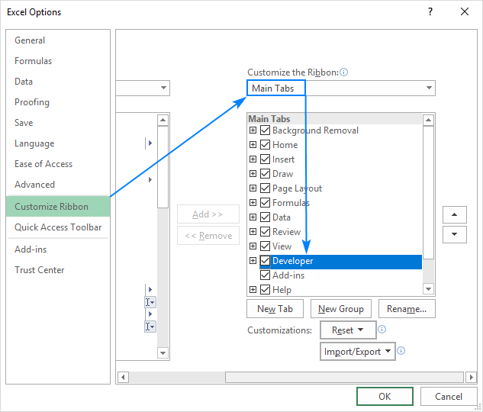

In the same manner, you can activate other tabs that are available in Excel but not visible on the ribbon, e.g. the Draw tab.

In addition to the ribbon that accommodates most commands available to you in Excel, a small set of frequently used commands is located on a special toolbar at the top of the Excel window for quick access, hence the toolbar name.  
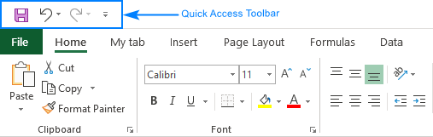

## 3. Architecture Description

**3.1. Data Description**

The Dataset contains Crop production based on years, season, state and district.

1. Order Date: The Date at which order was placed
2. Ship Date: The date at which the order would be shipped
3. Aging: Days to ship the product.
4. Ship Mode: The mode through which the order would be shipped
5. Product Category: The respective product category of the ordered item.
6. Product: The name of the product which was ordered.
7. Sales: Amount of the order
8. Quantity: quantity of items in each order.
9. Discount: discount on each order
10. Profit: Profit on each order
11. Shipping Cost: Cost of shipping the item(s).
12. Order Priority: Priority category of the respective order.
13. Customer ID: The id of the customer making the order.
14. Customer Name: Name of the customer making the order.
15. Segment: Respective segment of the product ordered.
16. City: Respective city of the customer.
17. State: Respective state of the customer.
18. Country: Respective country of the customer.
19. Region: Respective region of the customer.
20. Months: Month in which order was made

**3.4 Deployment.**

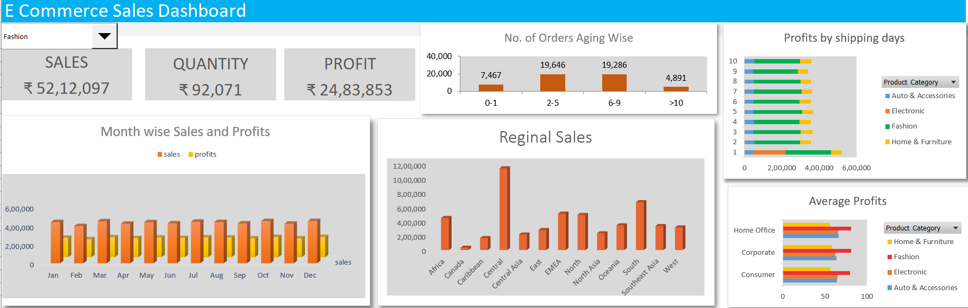

## 4. Unit Test Cases

|  |  |
| --- | --- |
| **TEST CASE DESCRIPTION** | **EXPECTED RESULTS** |
| **Monthly Sales** | Create a visual showing profit and sales month-wise |
| **Regional Sales** | Sum of sales present in a chart. |
| **Aging** | Frequency of order based on shipping days |